**Elements, Compounds and Mixtures**

Use the textbook or your device to find definitions for and draw a simple diagram of the following scientific terminology.

|  |  |  |
| --- | --- | --- |
| **Scientific Terminology** | **Definition** | **Diagram** |
| Atom |  |  |
| Compound |  |  |
| Element |  |  |
| Mixture |  |  |
| Molecule |  |  |

Fill in the missing words in the definitions below. Each word is used only once.

Missing words: **elements, different, one, joined, atom, type, two, substances**

* An **element** consists of ______ ______ of _______.
* A **compound** contains _____ or more __________ ______ joined together.
* A **mixture** contains two or more _________ which are not chemically  
    
  ________.

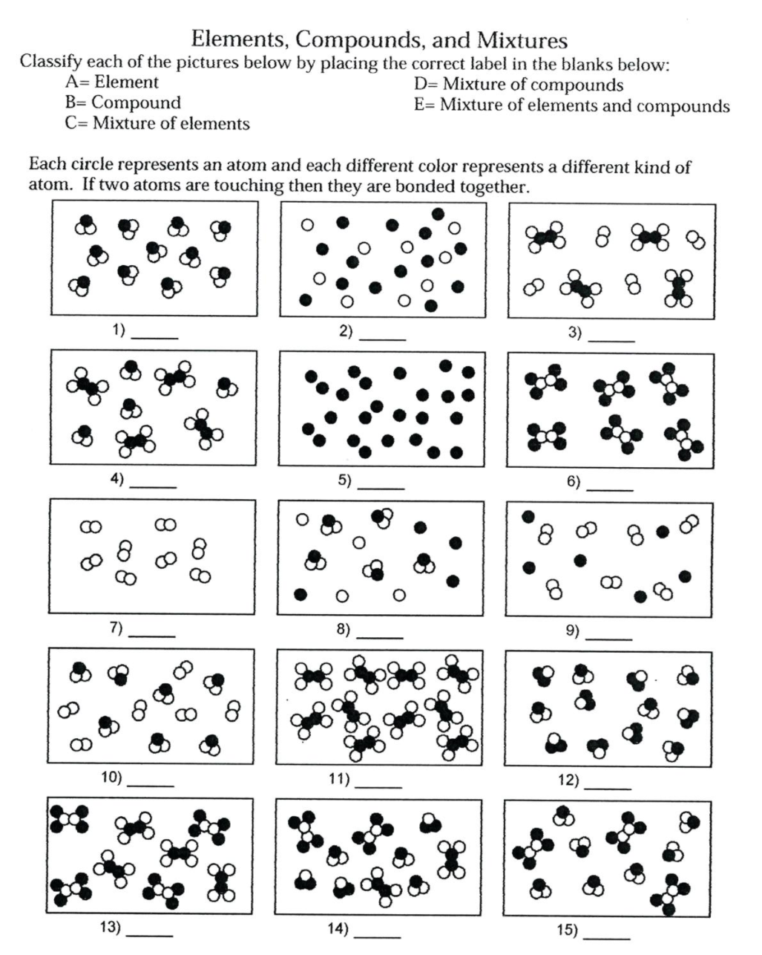

**Compound Formulae**

Elements combine in predictable ways to make compounds. For example, a **water** molecule is always formed when **one oxygen** atom combines with **two hydrogen** atoms. The chemical formula for water is _________.

For each of the compounds below, state which elements the compound contains and how many there are of each.

|  |  |  |
| --- | --- | --- |
| **Name of Compound** | **Formula of Compound** | **Number of Atoms of Each Element** |
| Carbon Dioxide | CO2 | 1 x Carbon  2 x Oxygen |
| Methane | CH4 |  |
| Calcium Chloride | CaCℓ2 |  |
| Copper Sulphate | CuSO4 |  |
| Sodium Carbonate | NaCO3 |  |
| Hydrogen Peroxide | H2O2 |  |
| Potassium Permanganate | KMnO4 |  |
| Aluminium Silicate | Al2SiO5 |  |
| Chloroform | CHCℓ3 |  |
| Copper thiocyanate | CuSCN |  |

**REMINDER**

**Atoms** are the simplest form of matter, consisting of a single particle only.

**Molecules** are made up of two or more atoms joined together by chemical bonds.

**Elements** are substances which are made up of one kind of atom only.

**Compounds** are molecules which are made up of at least two different kinds of atoms joined together by chemical bonds.

The diagrams below represent substances which are either atoms or molecules, and elements or compounds.

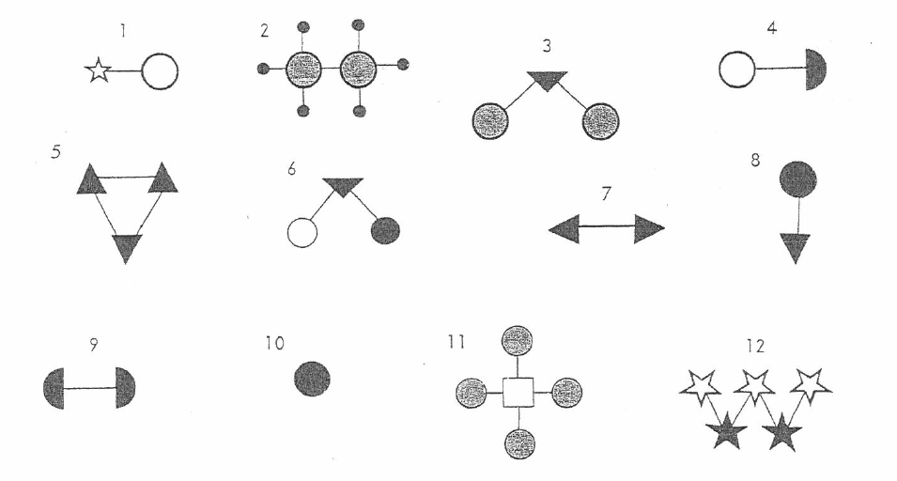



Complete the table below by writing the numbers (1 – 12) from the diagrams in the appropriate columns.

|  |  |  |  |
| --- | --- | --- | --- |
| **Atomic**  **Element** | **Atomic**  **Compound** | **Molecular**  **Element** | **Molecular Compound** |
|  |  |  |  |

One of the columns in your table should be empty. Which one? Explain why it is empty.